MCKV INSTITUTE OF ENGINEERING

Computer Science and Engineering – Data Science

***Name - Abhinaba Sarkar***

***Roll No. - BTECH/CSE-DS/2020/47***

**Assignment Number:** 4

Problem statement:

Write a python to generate Fibonacci Series up-to n terms using loop.

Assignment 4.a)

Source code:

t=int(input("Enter how many terms: "))

f,s,i= 0,1,0

if t <= 0:

print("Invalid input")

elif t == 1:

print("\nFibonacci series up to",t,"terms:")

print(f)

else:

print("\nFibonacci series up to",t,"terms:")

while i < t:

print(f)

n = f + s

f = s

s = n

i = i+1

output:

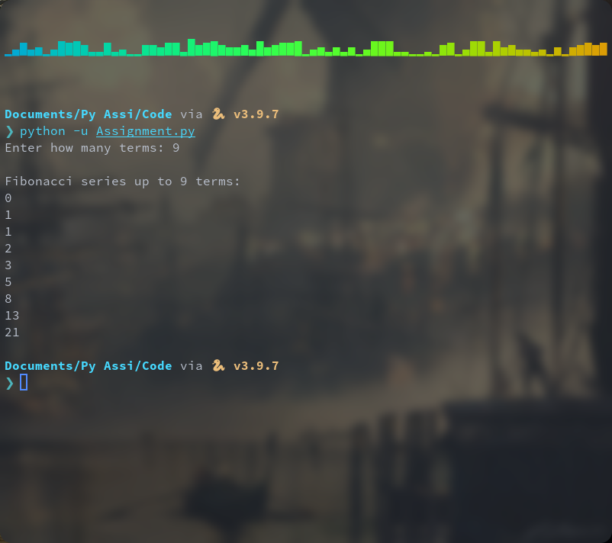

Problem statement:

Write a python program to generate all Prime Numbers within a range, where range is user input.

Assignment 4.b)

Source code:

lower=int(input("Enter the starting value of range:"))

upper=int(input("Enter the ending value of range:"))

for num in range(lower, upper + 1):

if num > 1:

for i in range(2, num):

if (num % i) == 0:

break

else:

print(num)

output:

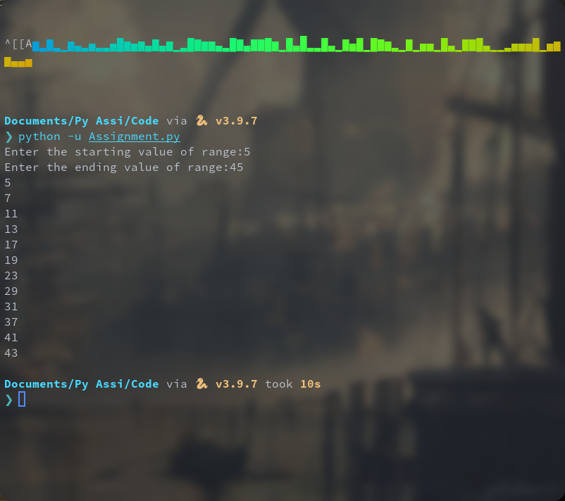

Problem statement:

Write a python program to reverse a number and check whether it is a Palindrome.

Assignment 4.c)

Source code:

n=int(input("Enter number:"))

temp=n

rev=0

while(n>0):

dig= n%10

rev=rev*10+dig

n=n//10

if(temp==rev):

print(temp," is a palindrome!")

else:

print(temp," isn't a palindrome!")

output:

